12-31-2012

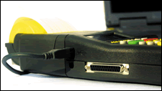

INSTRUCTIONS FOR ALGE TIMY and TIMY2

This guide is in two sections. Skip to the USB section (page 20)if desired

THE ALGE TIMY IS A DEVICE THAT USES “FLASH” MEMORY TO UPDATE THE SOFTWARE (FIRMWARE). THE TIMY HAS BEEN DELIVERED WITH SEVERAL USEFUL PROGRAMS:

- STOPWATCH IS A STAND ALONE PROGRAM FOR TIMING SANCTIONED RACES. IT WILL DRIVE AN ALGE GAZ DISPLAY AND PRINT OUT BASIC RANKINGS. ALL OF THE OUTPUTS TO SOFTWARE ARE THE SAME AS BACKUP. YOU CAN TIME TWO RUN RACES AND CREATE TOTAL TIMES
- DUAL TIMER WILL ALLOW YOU TO TIME HEATS WITH EITHER SEPARATE OR COMMON START PULSE. USEFUL TO CONTROL DISPLAYS FOR CYCLING ROAD RACES TOO.
- PARALLEL SLALOM IS FOR PRO STYLE SKIING, PURSUIT CYCLING
- PC TIMER IS A PROGRAM LIKE BACKUP THAT EUROS USE FOR RUNNING 10THS TO EURO SOFTWARE.
- BACKUP, IS A MULTILANE PROGRAM FOR HANDTIMING OR FOR “STUPID” USE WITH SOFTWARE.
- TRACKTIMER, IS A PROGRAM FOR SINGLE START WITH 8 FINISHES FOR TRACK AND FIELD OR SWIMMING.
- TRAINING, IS A SKI OR CYCLING TYPE TRAINING PROGRAM FOR AUTOMATIC TIMING OF SINGLE COURSE EVENTS.
- LAPTIMER, SIMPLE LAPTIMER FOR MOTORSPORTS OR CYCLING USE TIMING DEVICE.
- CYCLESTART IS A PROGRAM FOR COUNTDOWN FOR VELODROME CYCLING
- COMMANDER IS A PROGRAM FOR CONTROLLING DISPLAY BOARDS
- SPEED IS A PROGRAM FOR CREATING SPEED TRAPS WITH SENSORS
- WIND SPEED IS A CONTROL FOR THE WS1 WIND GAUGE ONLY
- TERMINAL IS FOR USE WITH PC PROGRAMS FOR SCORING

BE ADVISED THAT ANY CHANGE TO THE TIMY FIRMWARE MIGHT UPSET THE RESULTS SOFTWARE AND THEY BOTH HAVE TO BE CHECKED.
BACKUP

- PRESS GREEN START BUTTON
- PRESS GREEN “OK”
- THE TIMY WILL NOW PROMPT YOU TO CLEAR THE MEMORY IF YOU WISH, YOU WOULD NORMALLY DO SO IF YOU WERE STARTING A NEW RACE
- YOU ARE NOW ASKED TO ENTER THE SYNC TIME, PRESS CHANGE (F3)
- TYPE IN THE TIME OF DAY YOU WANT TO SYNC TO, KEEP PRESSING ZEROS TO SCROLL AROUND IF YOU MAKE A MISTAKE
- PRESS GREEN “OK” TO MOVE TO DATE (ENTER IT IF YOU WANT)
- PRESS GREEN “OK” AGAIN TO GET READY TO RECEIVE THE SYNC IMPULSE, (DO NOT PRESS GREEN “OK” UNTIL YOU ARE READY TO SYNC)
- THROW THE START WAND CONNECTED TO THE C0 BANANA PLUG INPUTS ON THE SIDE OF THE TIMY OR PRESS THE GREEN “START” FOR A NON SANCTIONED RACE, THE SYNC TIME WILL NOW PRINT
- TIME OF DAY IS NOW RUNNING ON THE UPPER PART OF THE SCREEN.
- THE NUMBER THAT PRECEDES THE RUNNING TIME IS THE CONTINOUS NUMBER THAT RECORDS THE GROSS NUMBER OF SPLITS
- THE SMALLER NUMBERS BELOW ARE YOUR RECORD NUMBERS THAT KEEP TRACK OF THE SPLIT NUMBER, THE CHANNEL IT CAME FROM AND THE TIME OF DAY
- THE GREEN START BUTTON IS YOUR MANUAL START AND WILL RECORD A “M” NEXT TO THE CHANNEL EVERY TIME IT IS PRESSED. IT WILL SEND THE START PULSE TO THE SOFTWARE
- THE RED STOP BUTTON IS YOUR MANUAL FINISH AND WILL RECORD A “M” AS WELL.
- THE LITTLE PRINTER ICON ADVANCES THE PAPER FOR EASE OF TEAR OFF
- HOLDING THE RED STOP BUTTON DOWN WITH THE POWER SUPPLY DISCONNECTED FOR 5 SECONDS PROMPTS TO TURN OFF TIMY (IT WILL ONLY ALLOW YOU TO RESET IT IF THE POWER IS CONNECTED)
- THE UP AND DOWN ARROWS ALLOW YOU TO SCROLL THROUGH THE SPLITS
- THE MENU IS REACHED BY PRESSING THE BARRED( STACK OF PANCAKES) KEY NEXT TO THE 2ND BUTTON.
- THE F O (ZERO) KEY ALLOWS YOU TO TOGGLE FROM “NORM” (PC) MODE TO “MEMO” (HAND TIMING MODE)
- THE STN KEY (F1) ALLOWS YOU TO ENTER A BIB NUMBER NEXT TO A SPLIT. SCROLL THROUGH THE SPLITS WITH THE ARROWS, PRESS STN, AND ENTER THE BIB, CONFIRM WITH THE GREEN ‘OK”
- DATA IS TRANSFERRED TO THE PC BY MEANS OF THE SPECIAL TIMY>PC CABLE. YOU WILL ALSO USE THIS CABLE TO UPDATE YOUR TIMY ONLINE LATER ON
- YOUR TIMY COMES WITH NICAD RECHARGEABLE BATTERIES AND MUST BE PLUGGED IN TO AC OR EXTERNAL 12VDC POWER FOR USE. THE FIRST THING THAT WILL STOP WHEN POWER GETS LOW IS THE PRINTER AND THE LCD WILL SAY THAT POWER IS LOW.

- PAPER REPLACEMENT IS SO EASY. PRESS THE RIDGES ON EITHER SIDE OF THE YELLOW PRINTER COVER AND ROCK BACK. NOTE HOW THE PAPER HAS “ALGE” LOGOS ON THE BACK SIDE. THREAD IT THROUGH AND CLOSE THE COVER.
- THE PHOTOCELL IS CONNECTED TO EITHER CHANNEL 1 OF THE BANANA PLUGS OR DIRECT TO AN ALGE CELL WITH THE DIN PLUG

SYNC FEATURE IN BACKUP AND PC TIMER

- YOU CAN SYNC ONE TIMY AND THEN USE IT TO SYNC OTHER DEVICES
- THIS ONLY WORKS WITH BACKUP AND PC TIMER PROGRAM
- PRESS THE GREEN AND RED “OK” BUTTONS DOWN WHEN THE TIMY APPROACHES THE TOP ON A MINUTE
- THE TIMY WILL SEND A PULSE OUT THE CHANNEL “0” BANANA PLUGS AT THE “0” POINT

DELAY SETTINGS FOR IGNORING EXTRA PULSES

- SOMETIMES YOU WILL GET EXTRA PULSES RECORDED FROM THE PHOTOCELLS DUE TO THE SPEED OF THE PASSAGE OR SNOW SPRAY. THE FACTORY DEFAULT SETTING IS 3 TENTHS (00.30 ) OF A SECOND.
- TO CHANGE PRESS THE MENU KEY/CHANNELS/INTERNAL/DELAY
- TYPE IN YOU NEW VALUE KEEPING IN MIND THAT A DELAY SET TOO HIGH MIGHT “SWALLOW” A FINISHER COMING RIGHT BEHIND. MORE OF A CONCERN IN BICYCLE TIME TRIALS OR XCOUNTRY SKIING THAN ALPINE.

PRECISION

MAKE SURE THE TIMY2 IS USING FULL 10,000S PRECISION. FIRMWARE UPDATES MAY ALTER THE PRECISION IN “BACKUP” DOWN TO 100THS!

- Press the MENU key (stack of pancakes
- Highlight “GENERAL”
- Press Green OK key
- Highlight Prec-Rounding
- Press Green OK key
- Highlight Precision
- Press Green OK key
- Scroll down and Highlight 10,000
- Press Green OK key to choose 10,000ths
- Check and make sure > is on 10,000
- Press left arrow key 4 times to return to timing

STOPWATCH
- THIS PROGRAM WORKS THE SAME AS STOPWATCH FOR THE FIRST RUN
- TURN THE TIMY OFF OR RESYNC IT FOR THE SECOND RUN
- IT WILL ASK IF YOU WISH TO TIME THE SAME OR NEXT RUN
- ENTER “NEXT” IF YOU WISH TO TIME THE SECOND RUN
- ENTER BIBO AND THE NUMBER TO FLIP OR OPERATE WITH SEQUENTIAL BIB NUMBER ONLY
- YOU CAN PRINT A RANKING LIST OF THE RUN TIME OR THE TOTAL TIME OR THE RUN TIME IN MEMORY
- YOU CAN SIMULATE A COMPLETE RACE USING THE START AND STOP BUTTONS

AUTOMATICALLY FINISHING THE NEXT RACER ON COURSE

The STOPWATCH program will allow you to automatically increment up to the next racer on course after each Start or Finish

- Press the Menu Key
- Highlight and press OK on GENERAL
- Highlight and press OK on STN-AUTOMATIC
- Highlight and press OK on FINISH
- You now have the option to select the entry of the “NEXT NUMBER TO FINISH” based on Manually, START, FINISH
- Highlight and press OK on FINISH
- The TIMY will now jump up and get the next number on course after each finish and create a net running time for them.
- You can also set this to work on the START as well. The incrementing works on the last starter. Therefore it is only useful with one number on course at a time

DUAL TIMER

- SELECT DUAL TIMER FROM THE MENU (YOU MUST UPGRADE TO AT LEAST V06.A6)
- THE REST OF THE SYNC PROCEDURE IS THE SAME AS THE REST OF THE PROGRAMS
- YOU THEN NEED TO DECIDE IF YOU ARE GOING TO HAVE SEPARATE STARTS OR A COMMON START.
- PRESS THE MENU KEY ONCE AND SCROLL DOWN TO THE DUAL TIMER SELECTION TO ALTER THE START TYPE OR LEFT COURSE NAME
- THE SCREEN AND THE CONTROLS ARE DIVIDED IN HALF, THE GREEN SIDE AND OK BUTTONS CONTROL THE LEFT (BLUE) SIDE AND THE RED SIDE CONTROLS THE RIGHT (RED) SIDE
- THE SMALL LCD SCREEN SHOWS THE RACERS ON COURSE WITH THE COURSE ID
- YOU TIME ONE HEAT AT A TIME
- ENTER A BIB NUMBER (UP TO 4 DIGITS) AND PRESS THE GREEN OK BUTTON TO PLACE A RACER IN THE LEFT (BLUE) START
- ENTER A BIB NUMBER (UP TO 4 DIGITS) AND PRESS THE RED OK BUTTON TO PLACE A RACER IN THE RIGHT (RED) START
- AN IMPULSE ON CHANNEL 0 OR CHANNEL 3 WILL START BOTH BIBS IF THE “COMMON YES” CHOICE WAS MADE. A SEPARATE START SELECTION USES CHANNEL 0 TO START RIGHT (RED) AND CHANNEL 3 TO START LEFT (BLUE) (COMMON NO)
- A FALSE START IS DEALT WITH THE SAME FOR BOTH SELECTIONS
- PRESS “CLR” FOLLOWED BY THE RED BUTTON TO CLEAR THE RIGHT (RED) OR “CLR” FOLLOWED BY THE GREEN OK BUTTON FOR LEFT (BLUE)
- FALSE FINISH WORKS THE SAME WAY.
- PRESS “CLR” FOLLOWED BY THE RED BUTTON TO CLEAR THE RIGHT (RED) OR “CLR” FOLLOWED BY THE GREEN OK BUTTON FOR LEFT (BLUE)
- YOU CAN START ANOTHER BIB RIGHT AFTER A FINISH HAS HAPPENED. THEREFORE YOU CAN STAGGER RACERS AND HAVE A CONTINOUS FLOW DOWN THE HILL IF YOU WANTED TO KEEP ALTERNATING FROM LEFT TO RIGHT START, ETC.
- THE DISQ KEY ALLOWS YOU TO DQ A RACER WHO HAS ALREADY FINISHED.
- ANYONE NOT FINISHING IS GIVEN AN ASSUMED DNF
- THE ARROWS ON THE RIGHT SIDE OF THE SCREEN AT THE BOTTOM BRING UP EDITING OPTIONS. THIS WAY YOU CAN ALTER A TIME BASED ON THE TIME OF DAY RECORDED. THIS IS SOMETHING TO DO AFTER THE EVENT OR IF YOU HAVE A BIG BREAK OF TIME DUE TO A COURSE MAINTAINCE ISSUE.
- RESULTS ARE PRINTED USING THE “CLASSEMENT” SELECTION
- YOU CAN PRINT THE RESULTS OF EACH COURSE OR OVERALL
- YOU CAN ALSO SELECT A RANGE OF NUMBERS TO PRINT AS A “CLASS” IF YOU HAVE SET UP YOUR BIB NUMBERS IN CONTIGUOUS GROUPS OR CLASSES.
- TIMING A SECOND RUN AND HAVING THE TIMES ADDED TOGETHER IS NOT AN OPTION CURRENTLY.
- GAZ SCOREBOARD USES ROTARY DIAL SETTING 1 FOR THE RIGHT (RED) AND ROTARY DIAL 2 FOR THE LEFT (BLUE)

NOTE: YOU CAN USE STOPWATCH/DUALTIMER WITH SPLIT SECOND. JUST TURN OFF THE RUNNING TIME OUTPUT. USUALLY JUST USE BACKUP AS IT IS LESS CONFUSING

MENU/INTERFACE/RS232/MODE and make sure that NETTO TIME is OFF

Sometimes you may see this setting also adversely effects how Split Second works and bibs will start automatically. The software is picking up parts of the running time string accidentally and using that fragment as another start.

YOU CAN ALTER THIS SETTING IN STOPWATCH/DUALTIMER , BUT NOT IN BACKUP OR PC-TIMER

Make The change and then go back to the other program.

DUAL TIMER FOR CYCLING

Dual Timer is very useful for road cycling applications running either GAZ 4 or D-line displays. PST makes a very useful CTS button adapter that allows one press to start and stop each time.

- Turn TIMY on and make sure that the starts are NOT Common. Described above.
- Insert DB 25 adapter into the side of the TIMY
- Insert the black banana plug into either Ch 0 or Ch 1 lower connection (ground)
- Insert the green banana plug into the Ch 0 input
- Type 1 followed by the Green OK button on the left (LAP) side of the TIMY
- Type 2 followed by the Red OK bitton on the right (Total) side of the TIMY
- Zeros will now appear on screen
- Press the CTS button to start both clocks
- You will now MOVE THE GREEN BANANA PLUG to the CH 1 input
- The GAZ or D-line displaying TOTAL time is set on Address 1, the LAP /@ time is on Address 2. They should both be set on HH:MM:SS , Option SE S 2 on D-line, Toggle down on GAZ.
- The riders are now coming around on their first lap.
- Press the CLR button followed by the Green OK when you see the leader. That will make the LAP display go to 0:00:00
- Now press the CTS button when the leader crosses the line. That will freeze the total time and start the LAP time from zero.
- Press CLR followed by the Red OK button to resume running Total time.
- Continue this sequence until the final lap.
- Press the CTS button when the winner crosses the line. DO NOT CLR anything. The winning time will be displayed on the Total display and the @ time will count up on the other.

TRACKTIMER
      - THIS PROGRAM WORKS WITH A SINGLE START AND MULTIPLE FINISHES EITHER FROM PHOTOCELLS OR PUSH BUTTONS.
      - THE NUMBERS IN THE UPPER LEFT OF THE SCREEN ARE HEAT NUMBERS.
      - ENTER A NEW HEAT NUMBER FOLLOWED BY THE GREEN ‘OK” BUTTON TO START A NEW HEAT.
      - IMPULSES RECEIVED FOR EACH CHANNEL WILL BE INCREMENTALY NUMBERED.
      - THE TIME CONTINUES TO RUN FOR EACH HEAT UNTIL OVERWRITTEN BY THE NEW HEAT
      - ALL CHANNELS ARE TREATED EQUALLY AND THE DELAY CAN BE ALTERED UNDER ; MENU-CHANNELS-INTERNAL-DELAY
      - PRINT DAYTIME ON UNDER; MENU-PRINTER-PRINT DAYTIME-ON , PRINTS THE HEAT # AND THE TIME OF DAY START FOR EACH
      - MEMORY HAS TO CLEARED FOR EACH NEW SESSION IF YOU WANT TO USE THE SAME HEAT NUMBERS (IE 1-20), SAVED MEMORY WILL NOT ALLOW YOU TO REUSE HEAT NUMBERS.

SPEED

- SELECT THE OPTION SPEED FROM THE MAIN MENU
- THE DEFAULT SETTINGS ARE 100M TRAP, KM/H , AND BIDIRECTION OPERATION BETWEEN CHANNEL 0 START AND CHANNEL 1 STOP, MIN SPEED 10 KM/H, MAX SPEED 200 KM/H
- THE UPPER LEFT HAND CORNER OF THE SCREEN SHOWS THE NEXT ID NUMBER TO START THE SPEED. IT IS SET TO INCREMENT UP AFTER EVERY START. YOU CAN OVER WRITE THE ID NUMBER BY INPUT ON THE KEYPAD FOLLOWED BY THE GREEN OK KEY
- CHANGE THE OPTIONS USING THE MENU. PRESS THE MENU KEY. SCROLL DOWN TO OPTION SPEED AND PRESS THE GREEN OK KEY TO CHANGE OPTIONS.
- DISTANCE MUST ALWAYS BE INPUT IN METERS.
- 5 meter = 16.404 feet
- 10 meter = 32.808 feet
- 30 meter = 98.425 feet
- 100 meter = 328.084 feet
- YOU CAN CHANGE THE SPEED DISPLAY UNDER UNIT TO; MPH, METERS/SEC, TIME
- YOU CAN ALSO INPUT A MIN AND MAX SPEED
- YOU CAN ALTER THE DIRECTION TO MAKE THE TRAP ONLY WORK IN ONE DIRECTION
- PRESSING THE LEFT ARROW KEY SEVERAL TIMES BRINGS YOU BACK TO THE TIMING SCREEN.
- YOU CAN REPRINT THE TIMES AND SPEEDS USING ; MENU>CLASSEMENT>ALL>PRINT MEMORY>START

MENU

THE MENU KEY LOOKS LIKE A STACK OF PANCAKES DIRECTLY TO THE RIGHT OF THE “2ND” KEY.

The “2nd” KEY MOVES YOU TO THE SECOND LEVEL OF VARIOUS MENU OR OPERATIONAL MODES.

THE LEFT ARROW KEY WILL ALLOW YOU TO EXIT FROM THE MENU

UP AND DOWN ARROWS TO MOVE THROUGH THE SELECTIONS

GREEN OK TO TOGGLE A SELECTION

INFO SCREEN

YOU CAN CHECK BATTERY AND POWER STATUS BY PRESSING AND HOLDING “2ND” FOLLOWED BY MENU. TRY UNPLUGGING THE POWER SUPPLY WHILE IN THIS MODE TO WATCH THE BATTERY STATUS CHANGE. THE “UBATT” VALUE IS THE STAND ALONE BATTERY STATUS. YOU CAN ALSO SEE IF ANY OF YOUR INPUTS ARE BLOCKED OR SHORTED( CH ID IS BLACKED OUT) . LEFT ARROW TO EXIT.

CHANGE PROGRAMS

YOU CAN TOGGLE BETWEEN PROGRAMS WITHOUT RESYNCING. SAY THE PC OR SOFTWARE DIES AND YOU ARE USING BACKUP. YOU CAN PRESS MENU, SCROLL TO PROGRAMS WITH THE DOWN ARROW. PRESS CHANGE (F0) IT WILL NOW CHANGE TO THE PROGRAM YOU SELECTED (STOPWATCH L)

DISPLAY BOARD

THE ALGE GAZ 82 (1982-1988) THE GAZC (1988-1994) AND THE GAZ4 (PST DISPLAYS) ALL WORK WITH THE TIMY. PLUG THE DISPLAY INTO THE FIRST SET OF BANANA PLUGS ON THE SIDE LABELED D-OUT. THE BOTTOM CONNECTOR IS GROUND AND THE TOP IS SIGNAL

PRINT MEMORY

PRINTING THE MEMORY OF THE TIMER MAY BE USEFUL IF YOU HAVE HAD TO TURN THE PRINTER OFF TO SAVE BATTERIES.

- SELECT MENU-CLASSEMENT
- SELECT ALL (OR A CLASS IF THEY EXIST)
- SELECT PRINT MEMORY OR THE SPECIFIC RUN TIME OR TOTAL TIME YOU WANT
- TMAKE SURE THE POWER SUPPLY IS ON
- PRESS START
- THE LEFT ARROW KEYS ALLOW YOU TO LEAVE AND TRY AGAIN IF YOU MAKE A MISTAKE.

SOFTWARE

- THE SPLIT SECOND USSA/FIS , NASTAR, and CLUB SOFTWARE IS READY TO GO WITH THE TIMY.
- SELECT TIMY 9600 BAUD IN THE SETUP AND TEST MENU
- THE CHANNEL 0 FOR START AND CHANNEL 1 FOR FINISH ARE THE DEFAULTS AND WILL WORK RIGHT AWAY
- NASTAR and/OR DUAL COURSE USERS WILL NEED TO ACTIVATE THE TWO ADDITONAL CHANNELS WITH AN ADAPTER BOX, ADAPTER CABLE OR TIDO.
- MAKE SURE THAT THE SERIAL PORT IS WORKING AND THAT THE DEVICE IS SENDING DATA.
- IF THAT FAILS YOU WILL NEED TO MAKE SURE THAT THE DATA IS GETTING INTO THE PC. DOWNLOAD “COM TO FILE” FROM THE ALGE SITE. IT IS ABOUT AS BULLETPROOF A TEST PROGRAM AS I HAVE SEEN.
- http://www.alge-timing.com/alge/download/software/comf.exe

TIDO DOCKING STATION

- THE TIDO CONNECTS TO THE DB25 CONNECTOR ON THE SIDE OF THE TIMY.
- YOU CAN POWER THE TIDO FROM THE TIMY
- THE SERIAL PC DATA CABLE PLUGS INTO THE TIDO “MULTIPORT” INPUT
- ALL CHANNELS AND THE HEADSET ARE NOW AVAILABLE

COM TO FILE DATA TRANSFER

COM TO FILE IS A VERY HANDY PROGRAM FOR DUMPING DATA FROM THE TIMY INTO AN EXCEL SPREAD SHEET.

- OPEN THE COM TO FILE PROGRAM AND CONNECT THE TIMY WITH THE DATA CABLE.
- MATCH THE BAUD RATE IN THE PROGRAM AND THE TIMER (DEFAULT SHOULD BE 9600)
- TRY TO SEE IF COM TO FILE IS RECEIVING TIMES FROM TIMY
- PRESS STOP BUTTON ON TIMY AND YOU SHOULD SEE THAT TIME APPEAR ON THE PC.
- PRESS RECORD TO BEGIN THE PROCESS
- SELECT A FILE NAME FOR YOUR DATA TRANSFER FILE
- PRESS MENU-INTERFACE ON TIMY
- PRESS RS-232
- PRESS SEND MEMORY
- WAIT UNTIL ALL OF THE TIMES ARE TRANSFERRED WHICH WILL BE SIGNALLED BY THE “ALGE-TIMING” TEXT AT THE END.
- PRESS STOP RECORD
- CHECK TO SEE THAT TIMES ARE RECORDED UNDER TABLE TAB
- EXIT THE COM TO FILE
- OPEN YOUR DATA FILE IN WORDPAD (YOU HAVE TO ADD COMMAS TO ALLOW EXCEL TO SEPARATE THE DATA LATER)
- THE TEXT FILE OF TIMES SHOULD APPEAR
- USE FIND-REPLACE TO CHANGE A SINGLE SPACE TO A COMMA, THEN A DOUBLE SPACE TO A COMMA, THEN A DOUBLE COMMA TO A SINGLE COMMA
- YOUR FINAL FILE SHOULD HAVE THE DATA SEPERATED BY SINGLE COMMAS
- OPEN EXCEL
- BROWSE FOR THE SAVED TEXT FILE THAT YOU MODIFIED ABOVE. MAKE SURE YOU CHOOSE THE .TXT FILE AND NOT THE .XLS
- EXCEL WILL NOW ASK YOU TO USE COMMA AS THE DELIMITER
- CHOOSE ALL OF THE DEFAULT SETTINGS AND THE FILE WILL BE IMPORTED IN COLUMNS THAT MAKE SENSE.
- ADD HEADERS TO THE COLUMNS
- HEAT #, CHANNEL ID # , TIME, PULSE COUNT
- YOU WILL NOTICE THAT THE TIME COLUMN DOES NOT LOOK RIGHT. IT NEEDS TO BE FORMATTED.
- HIGHLIGHT THE COLUMN WITH THE RIGHT MOUSE BUTTON
- SELECT FORMAT CELLS
- SELECT CUSTOM
- SELECT A TIME FORMAT AND THEN OVER WRITE IT IN THE TYPE BOX
- HH:MM:SS.000
- THE TIMES SHOULD NOW MAKE SENSE TO THE 1,000THS
- CUT AND PASTE THE DATA AS NEEDED.

UPDATING FIRMWARE via serial connection (Try to use the USB connection described later in the guide first)

To update your Timy to the latest firmware revision, go here:

http://www.alge-timing.com/alge/download/uC/index-1e.html
Download the Installation Manager (it is in English). It is located on the right hand side of the options at the bottom. Then download the latest firmware update from the same page. Left hand side of the page. Make sure you know where the folder is where the TIMY.exe file is. You will need that info later in the process.

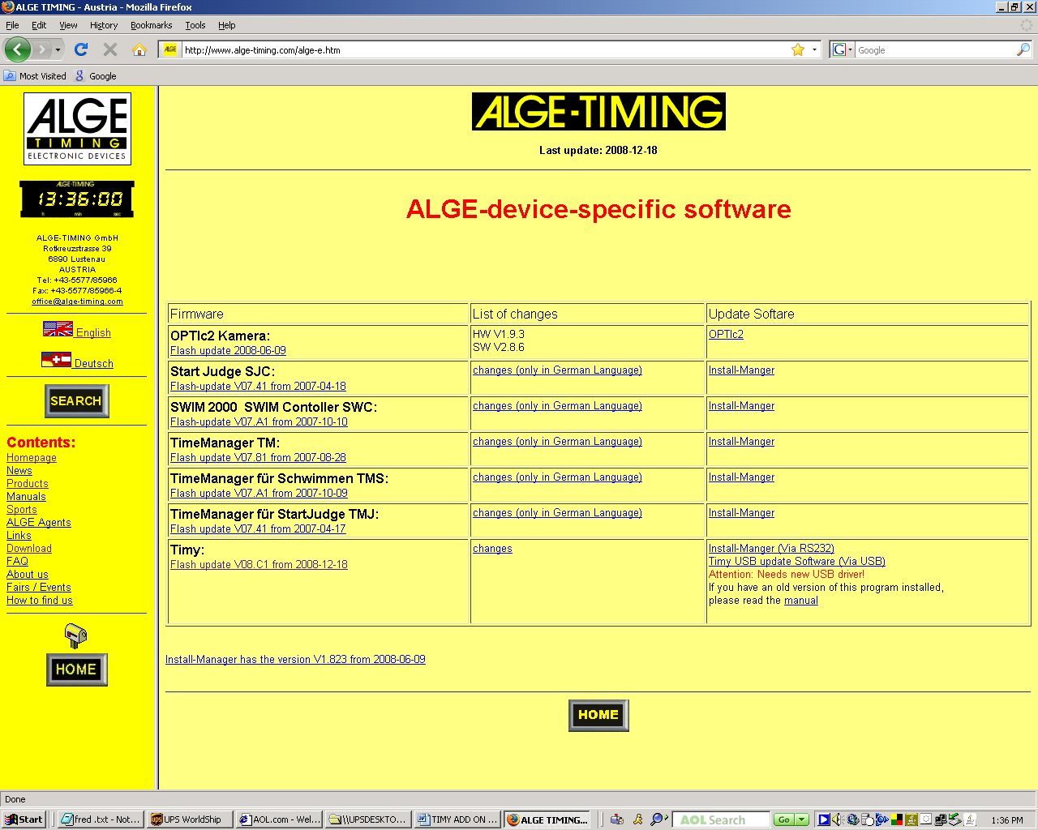

You'll need a full-duplex serial cable customized for the Timy, you almost surely already have one, if you can log Timy TODs on your PC.
Hook up the Timy to your PC using the aforementioned cable, run the Installation Manager, click the FIRMWARE tab, and follow the directions onscreen.

The TIMY picture will appear when the connection is made. You may have a serial interface issue if you cannot get the picture to appear as it is in the lower screen shot.

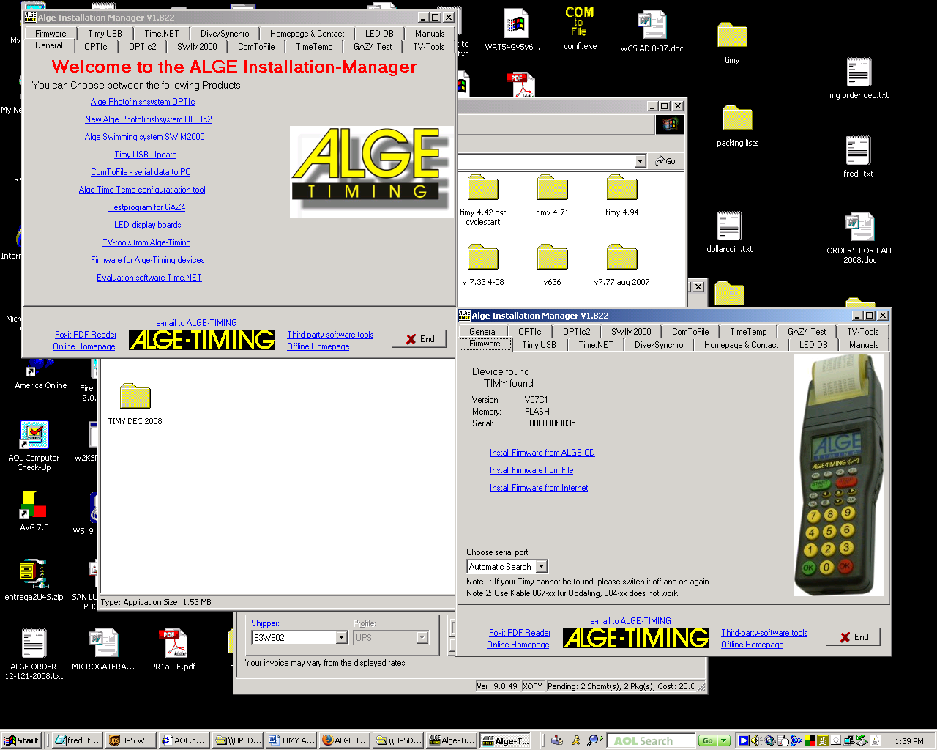
The process basically erases the current program and then reprograms the TIMY.

The sequence will be:

- Erasing the flash
- You may be asked to turn the timer on and off at this point. Older TIMY’s may have to have the batteries removed and use the AC power supply to force the issue
- The TIMY screen with say “UPDATE BY USER” if the process is ok
- The on screen prompt will then ask you to tell it where to find the new program called TIMY.exe
- This should have been downloaded to a new folder already.

You can also use USB connections to do the updates. That requires different install manager, etc.

SPLIT SECOND USSA/FIS SCREEN SHOT

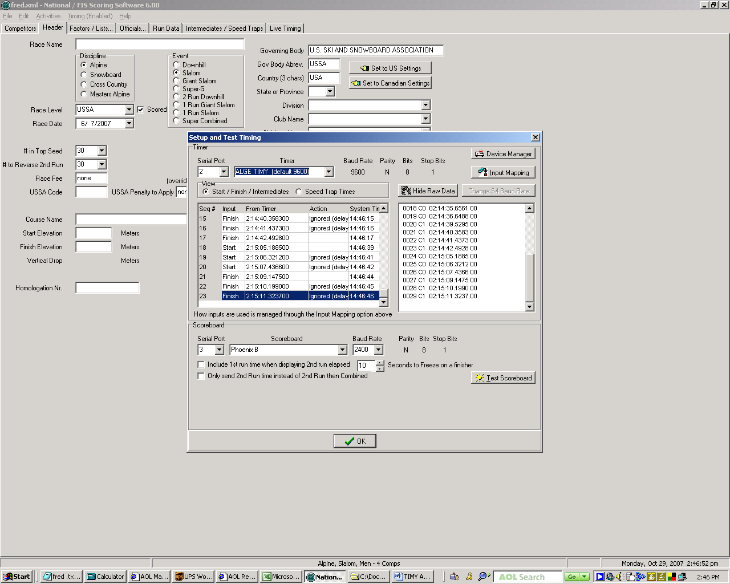

SPLIT SECOND CLUB SCREEN SHOT

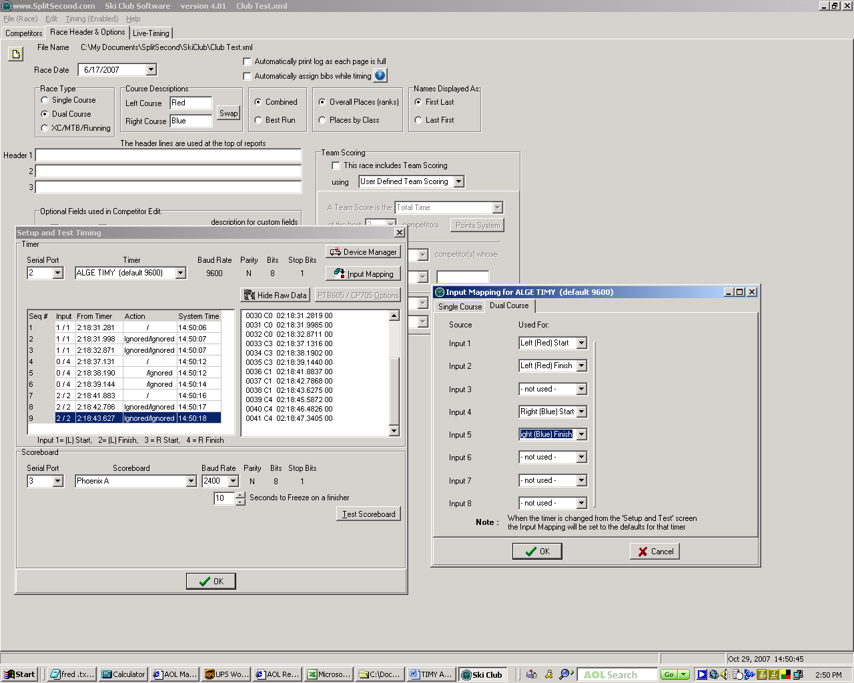

NASTAR SCREEN SHOT

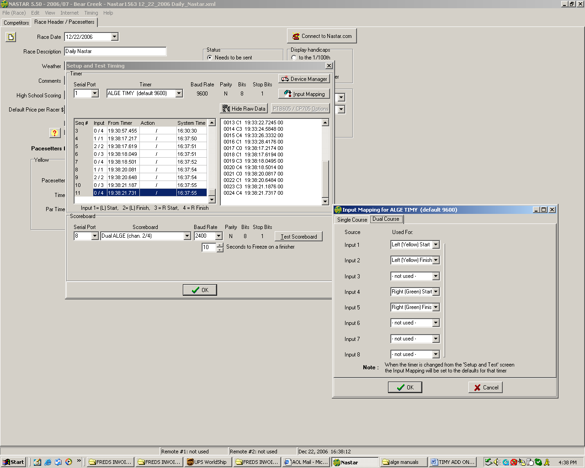

THERE IS AN ADDITIONAL OPTION FOR “TIMY DUAL TIMER” WITH CHANNEL 3 =GREEN START, CH 4= GREEN FINISH

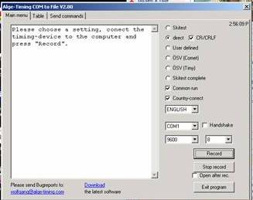

ALGE COM TO FILE SCREEN SHOT

TIMY USB INTERFACE WITH SPLIT SECOND NATIONAL FIS/ CLUB/ NASTAR

Split Second software is now 100% USB compliant with the TIMY. Installing the new software will allow the operator to choose between, BACKUP, PC TIMER , and STOPWATCH as timing programs to use.

Note: Make sure that you have the TIMY selected as ALGE DUAL TIMY dual timer (9600) in the Split Second timer selection drop down under the Serial Timer settings if you are using dual courses. That sets up the channels properly so that the USB interface uses them correctly. Otherwise your Blue or Green course will not function even though the TIMY is printing the splits. Make sure you set the selection of a Serial Port in the Serial Timer settings to “none” once you are done so that it does not interfere with the output to the display or other output trying to use that serial port number.

CHANNEL ID

RED /YELLOW/RIGHT START = CHANNEL 0 – MIDDLE BANANA PLUG SOCKETS WITH TOP SOCKET BEING SIGNAL, BOTTOM BEING GROUND

RED/YELLOW/RIGHT FINISH = CHANNEL 1 – RIGHT HAND BANANA PLUG SOCKETS WITH TOP SOCKET BEING SIGNAL, BOTTOM BEING GROUND, OR DIRECT DIN CABLE IN FROM CELL

BLUE/GREEN/ LEFT START = CHANNEL 3 – GREEN/BLACK ADAPTER SOCKET OR LOOSE FEMALE BANANA PLUGS, GREEN BEING SIGNAL, BLACK BEING GROUND

BLUE/GREEN/LEFT FINISH = CHANNEL 4 – RED / BLACK ADAPTER SOCKET OR FEMALE BANANA PLUGS, RED BEING SIGNAL, BLACK BEING GROUND

Installing the USB interface is a multistep process. DO NOT connect your TIMY until later. Remember that USB interfaces normally are only good for one specific port on the PC. You will have to do this again if you plug the TIMY into another port or USB hub.

Steps:

- Download ALGE driver and unzip into C:/driver
- Plug TIMY in and follow Windows New Hardware wizard
- Select specific place for installation drivers and browse to C:/driver/TimyUsb
- Open Split Second
- Select TIMY USB and open ALGE Control
- Attempt to open Timy listed with Open button. Close Split Second if no “heartbeat”. If you see “heartbeat” you are already good to go
- Download and run ALGE COM to FILE program to “clear a pathway” for Split Second. Press up to USB in “COM” port setting of Com to File
- You MUST see the “heartbeat” here in ALL ALGE programs. If you don’t you will not see it in Split Second
- A “heartbeat” here in Com to File means shut it and reopen Split Second

MAKE SURE YOU USE THE USB/TIMY DRIVER SOFTWARE VER 2.50 OR HIGHER FOR THE TIMY2!

Connect your PC to the Internet and install new Split Second software first.

http://algetiming.com/download/Software/Driver/TimyUSBDriver.exe

Open the SETUP AND TEST screen

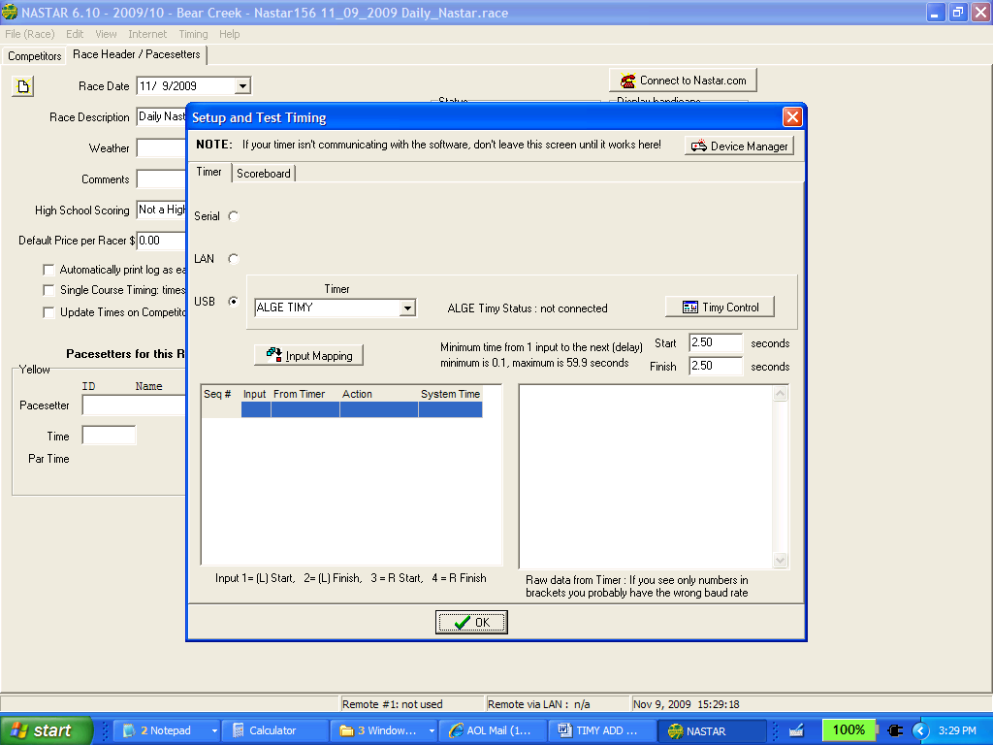

Press the TIMY CONTROL button

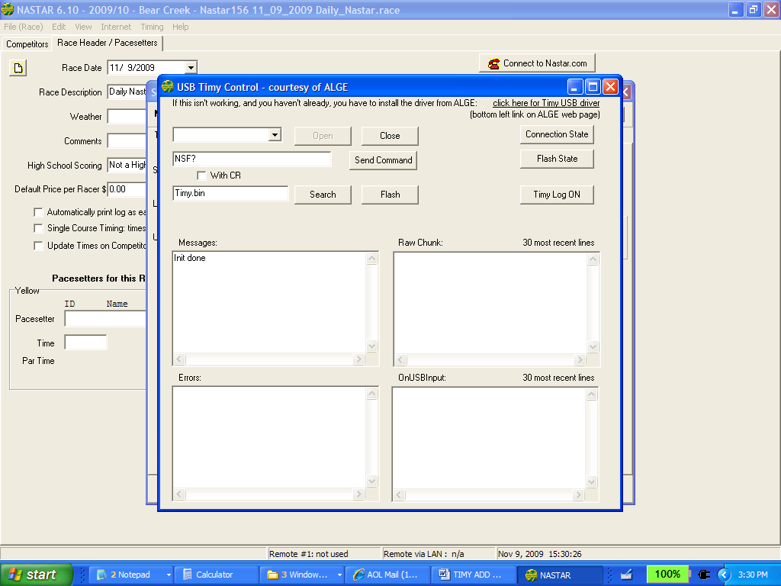

Note: Never press the “FLASH” button on this screen unless you want to update the firmware on the TIMY. Pressing this without updating creates problems for the timer and software.

Click on the TIMY USB driver link in the upper right hand corner of the screen.

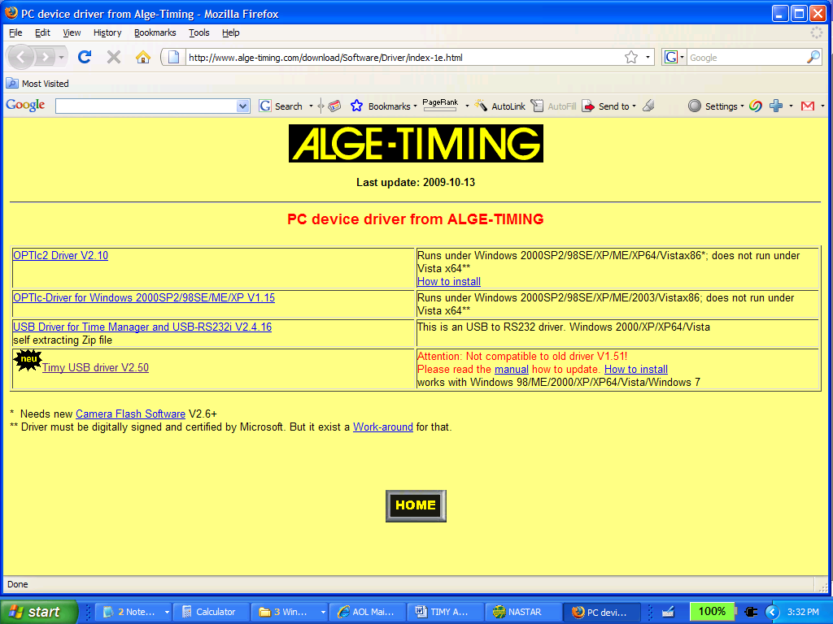

Download driver from ALGE in lower left corner. Ver 2.50 or higher!

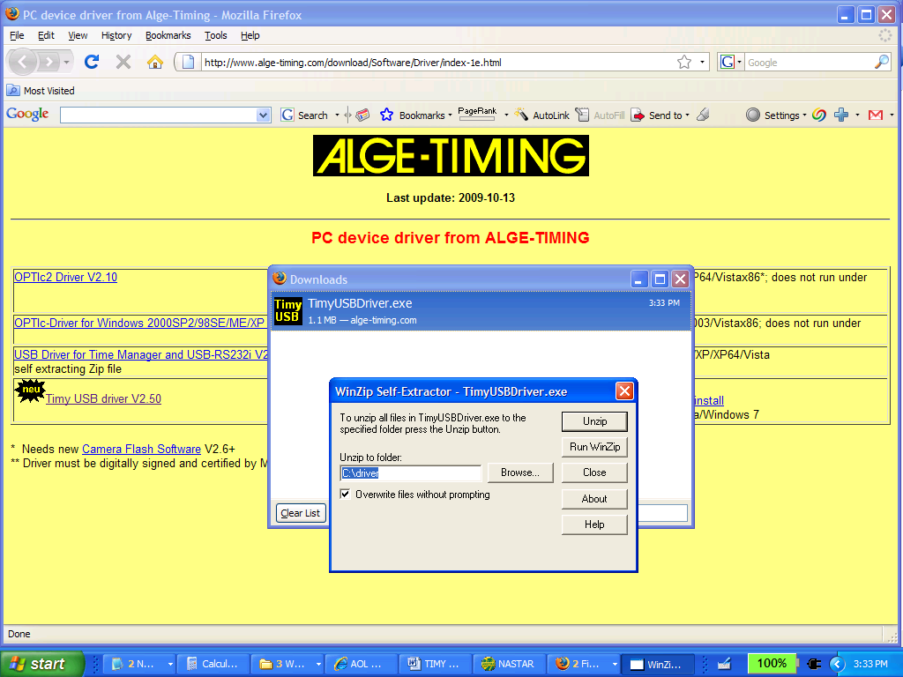

Open the .zip file and allow it to create the new folder C:\driver. 16 files will be created. Close the Win Zip program, the ALGE website, and Split Second.

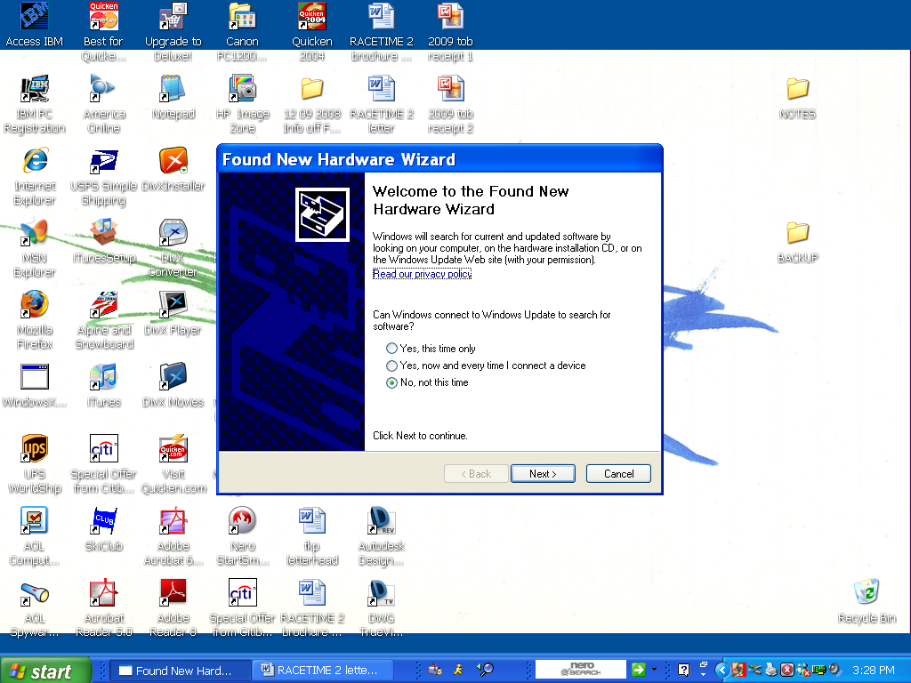

Connect your TIMY to the PC. The Wizard will start trying to find a driver for the USB device. Do not connect to Internet

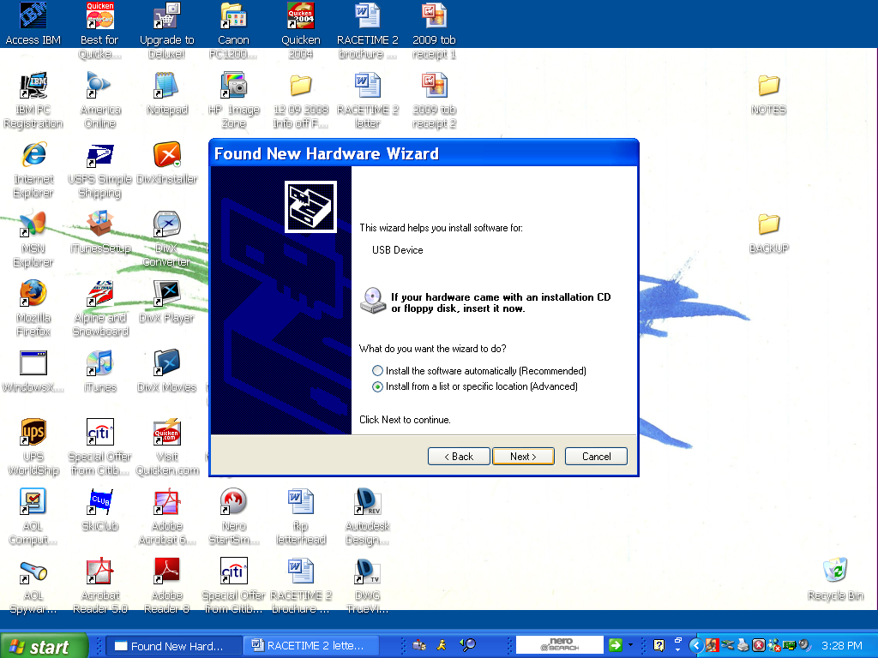

You want to choose the ability to select a specific location for the driver

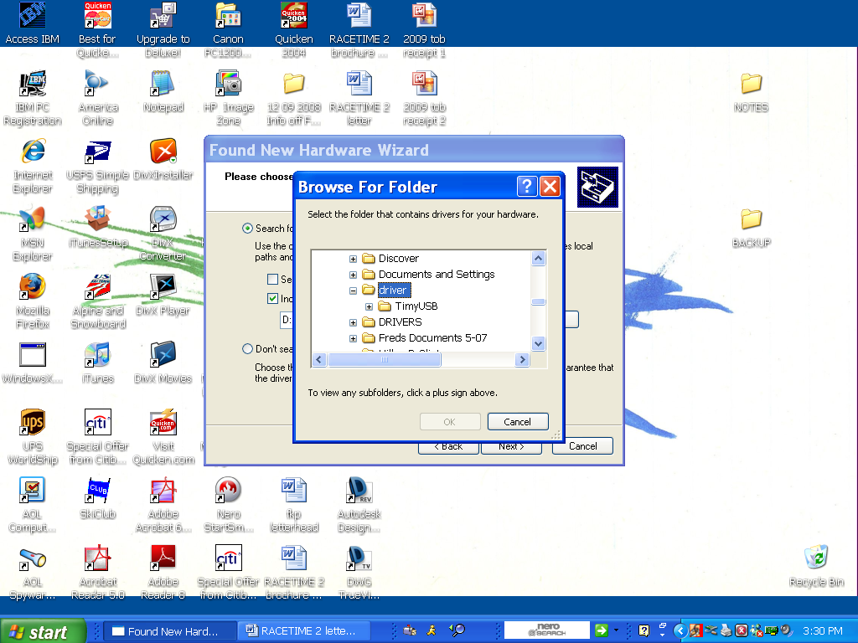

Browse for the folder C:\driver

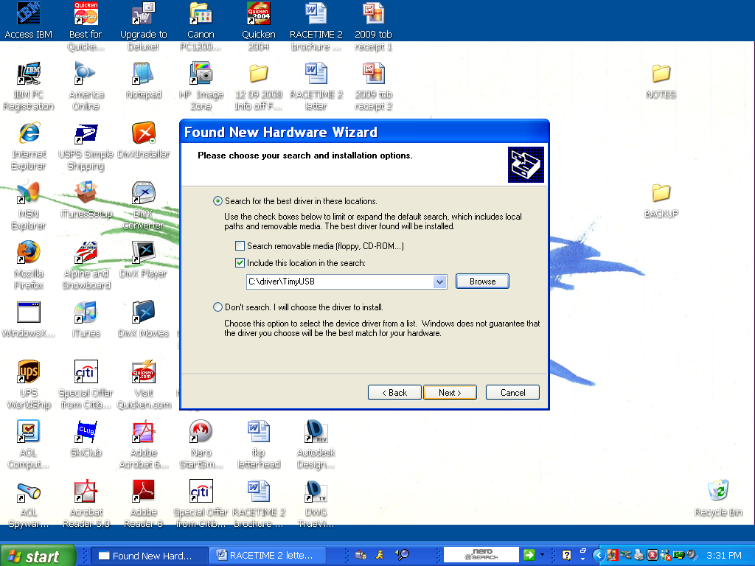

Make sure that the folder selected is C:\driver\TimyUSB. NO SUBFOLDERS in the driver directory!

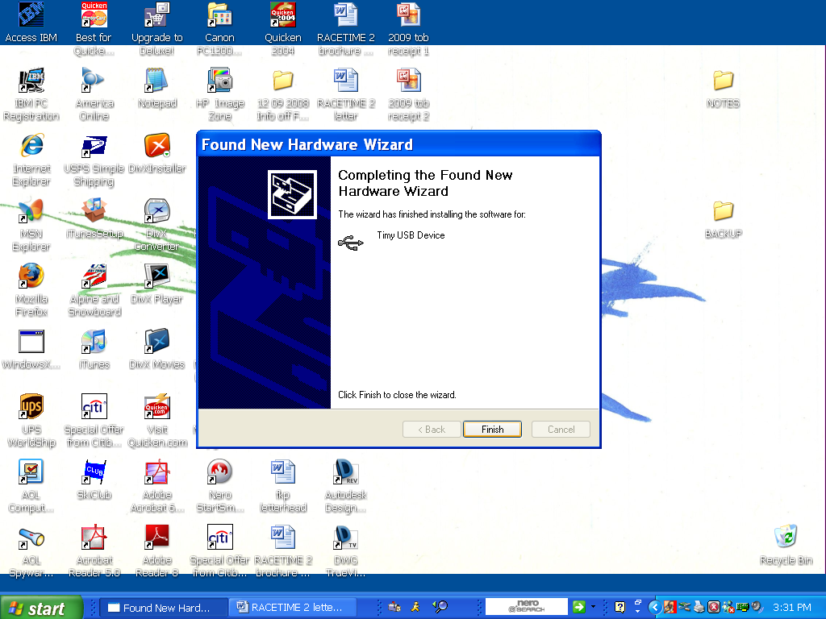

Let the wizard complete it’s task of installing the driver. Press Finish.

Restart the Split Second software. Open the SETUP and TEST screen again.

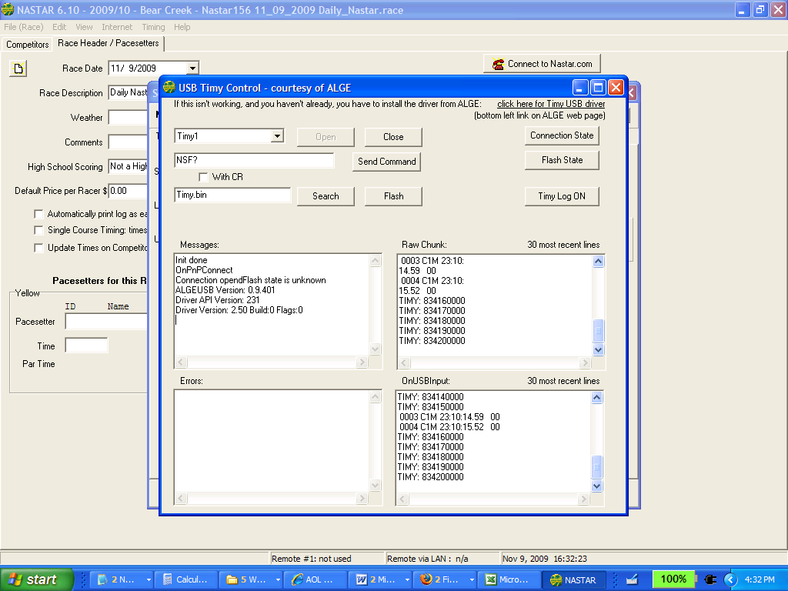

The TIMY will now be sending data to the USB TIMY control screen. Close this if it is working.

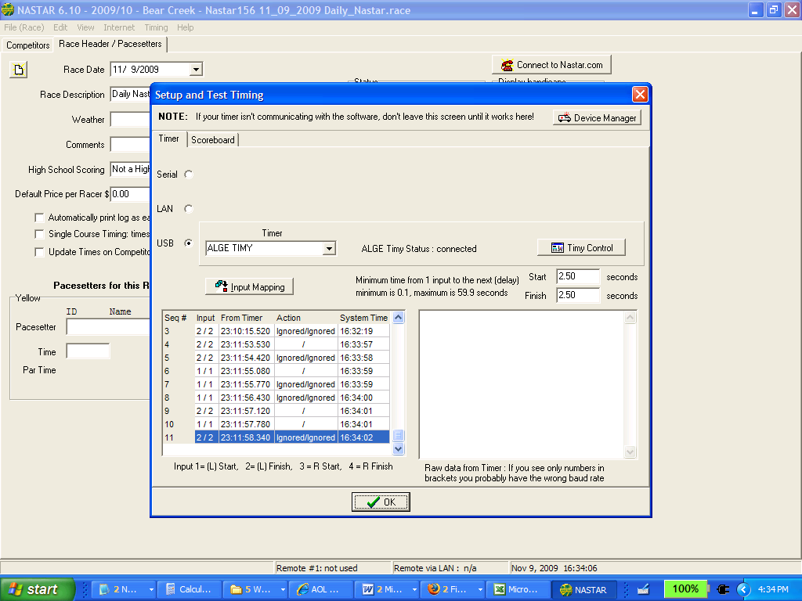

Now check your main screen and make sure that your inputs are correct. All of the settings from the serial connection will work just fine with the USB connection.

NOTE: Make sure that the Serial Settings are for “TIMY DUAL TIMER at 9600 Baud” if you intend to use dual timing for NASTAR or CLUB. The software keys off the serial settings to properly set up for dual timing.

USING ALGE COM TO FILE TO CLEAR PATHWAY TO USB CONNECTION

Some PC users have found that running ALGE Com to File assists in making the USB connection.

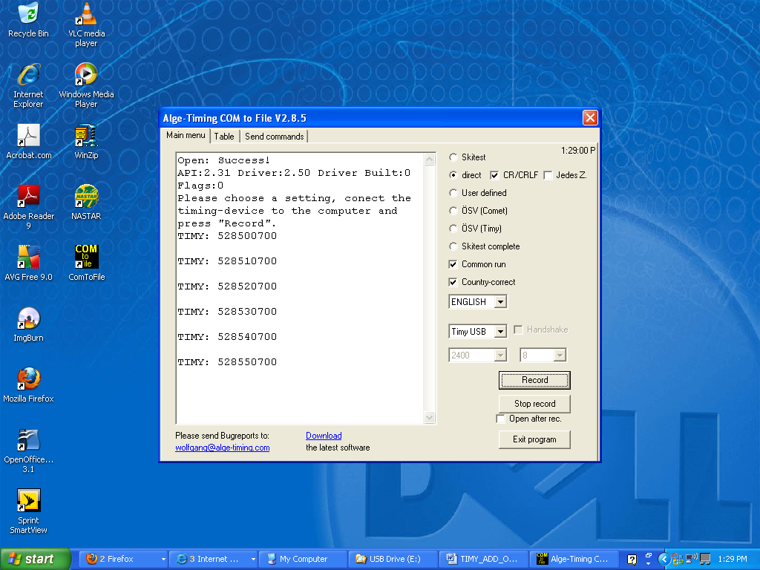

Download the Com to File program.

http://algetiming.com/alge/download/software/comf.exe

Make sure that you select “English “ for the language.

The “TIMY USB” selection is one selection above the default “Com 1”

UPDATING THE TIMY VIA USB

- Download the USB update program from ALGE.
- http://www.alge-timing.com/alge/download/software/TimyUSB.exe
- Install the software.
- Download the latest TIMY firmware from ALGE
- http://www.alge-timing.com/alge/download/uC/timy.exe
- Connect the TIMY via the USB cable and start the program.
- Press the OPEN button to connect to the TIMY
- Use the Search button to point the program to the location of the TIMY.exe file you downloaded.
- Press Update and let the program work
- It will restart the TIMY at the end with the new program.

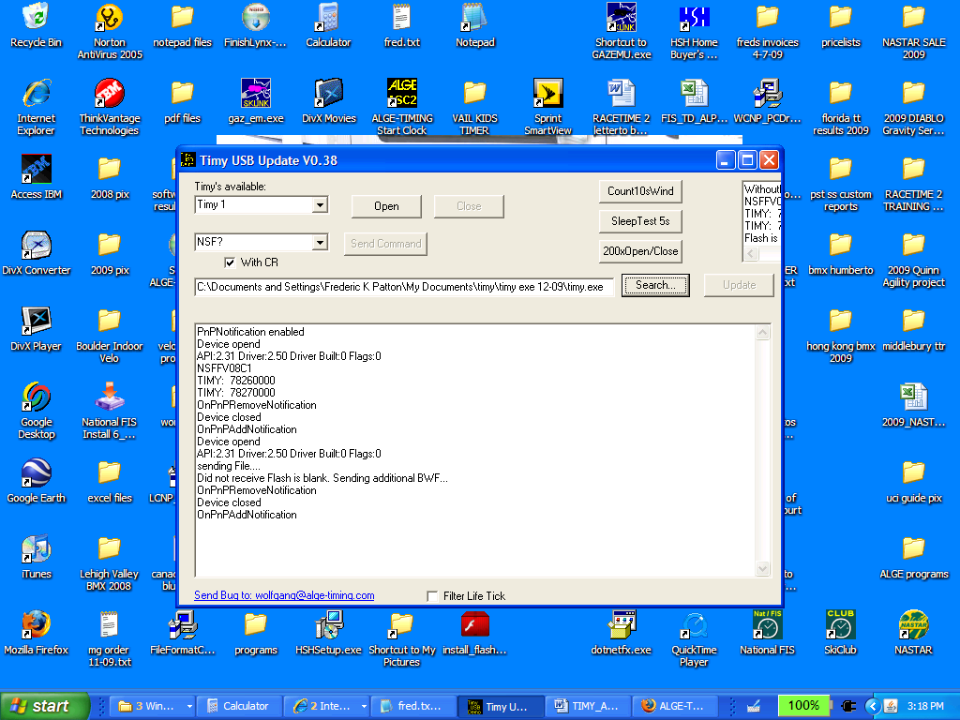

Output to scoreboard stalls with USB to serial adapter.

Make sure that the serial setting for the Timer is set to NONE even though you will be using the USB connection.

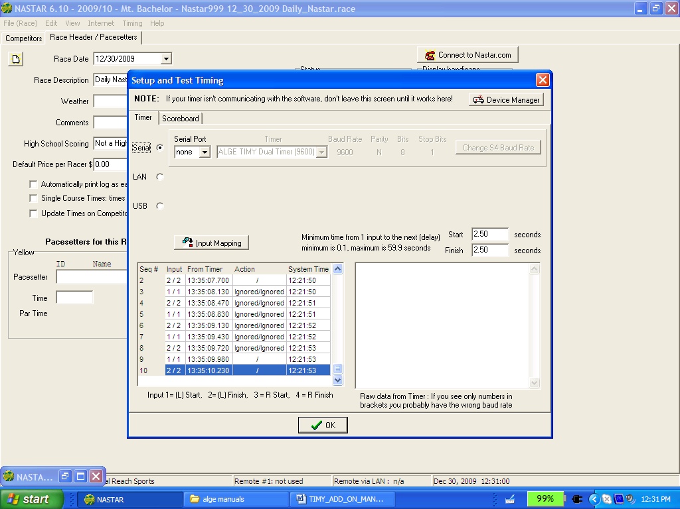

Windows 7 (32 Bit)

Download and install the TIMY or TIMY2 driver in the same manner as before creating the C:\driver folder.

• Plug the TIMY into the USB port

• You will probably get an error message telling you that the driver cannot be found.

• Go into Device Manager

• Click on Unknown Device with the exclamation point

• Update Driver

• Browse my computer for driver software

• Browse to C:\driver\TimyUSB

• Click NEXT

• Install this software anyway at error message

• You will see the label Timy USB device when you are done

• Close

• Close

• Open ALGE COM to FILE

• Download from www.algetiming.com pc software and install if needed

• The program comes up German (Deutsch)

• Click down to ??? and it will let you select English.lng

• Click up on COM port settings to select USB

• You will now see the “heartbeat” from the Timy

• Exit COM to File

• Open Split Second

• Timing/Setup and Test

• USB selection TIMY

• It may connect already, otherwise go to Timy Control

• You MUST see the “heartbeat” in Timy Control before continuing

• Reboot computer and try again if needed.

Link to ALGE Manual on Windows7

http://algetiming.com/alge/download/manual/timy/Timy%20Driver%20installation%20Win7-E.pdf

Notes on Windows 8

These are from the ALGE Website

http://alge-timing.com/download/Software/Driver/index-1e.html

Important hint for driver installation under Windows 8
Windows 8 needs signed device drivers. Unsigned drivers like we have, can be installed, but it is very tricky.
You must execute the following commands as administrator:
bcdedit -set loadoptions DISABLE_INTEGRITY_CHECKS
bcdedit -set TESTSIGNING ON
shutdown /r /o
You can download this batch script here.
After the restart you should be able to install the drivers properly
We are working on a better solution right now.

Differential Timing with Split Second Club and NO dual course adapter

You can successfully use a TIMY with only the built in Channel 0 and Channel 1 inputs to time head to head racing. The major thing that needs to be done is work around the default input mapping for “Dual Course” racing with the USB connection. Remember to go back to the selection of TIMY USB after modifications so that the connection will be restored.

The single course default settings have been created based on the standard ALGE designation of Dual Timer 9600 baud which is one of the last in the selection list near the bottom.

Channel 0 = Input 1 = Red/Yellow Start

Channel 1 = Input 2 =Red / Yelllow Finish

Input 3 = not used

Channel 3 = Input 4 = Blue/ Green Start

Channel 4 = Input 5 = Blue/ Green Finish

The Club software (Ver 6.04 rev 11) picks the default settings for Differential based on the older ALGE default 9600 settings which were created first.

These settings are:

Channel 0 = Input 1 = Red/Yellow Start

Channel 1 = Input 2 =Red / Yelllow Finish

Channel 2 = Input 3 = Blue/ Green Start

Channel 3 = Input 4 = Blue/ Green Finish

If you have a dual channel adapter you can just use the banana plug input that will get you channel 3 (Blue finish on older adapters, Blue Start on newer) and you will be all set for the Blue course. This section of the guide deals with how to make the software recognize the other option.

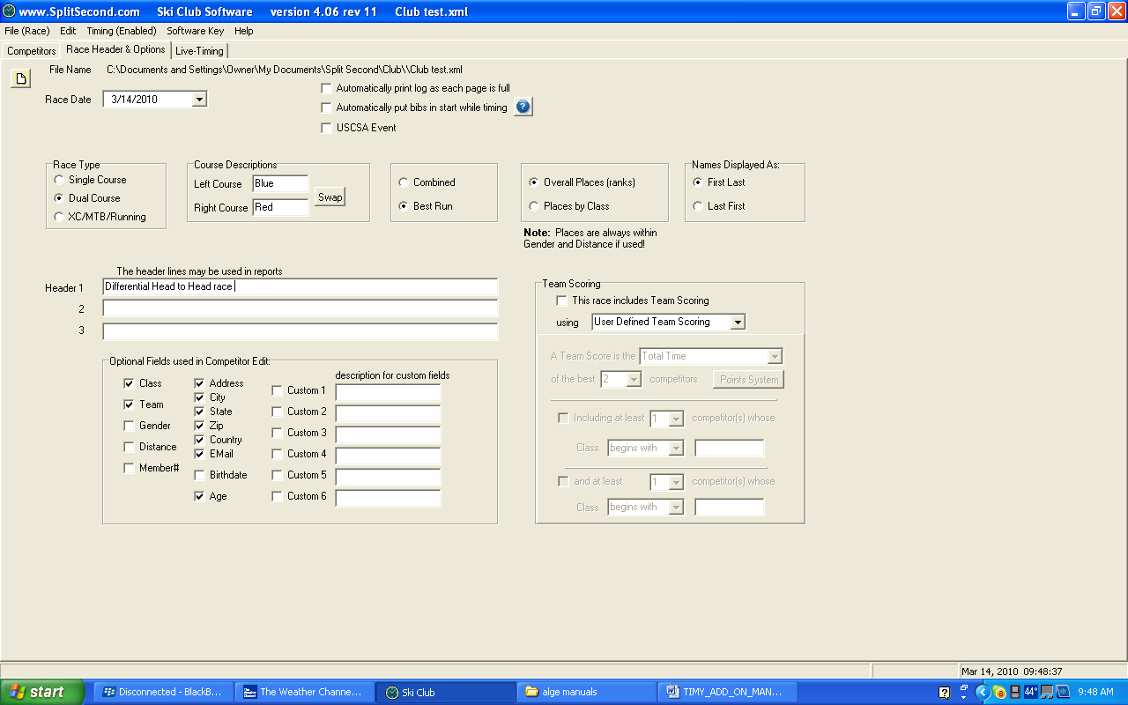

Initial setup screen. We have swapped Blue and Red colors to make it RED/RIGHT

You will now need to go into Setup and Test and Select the Serial TIMY setting that you can. Very often a PC will have the availability of a serial port like Com 3 or 4 that is really used for an infrared port or other use. Try to stay away from the port used by a USB to serial adapter for your scoreboard.

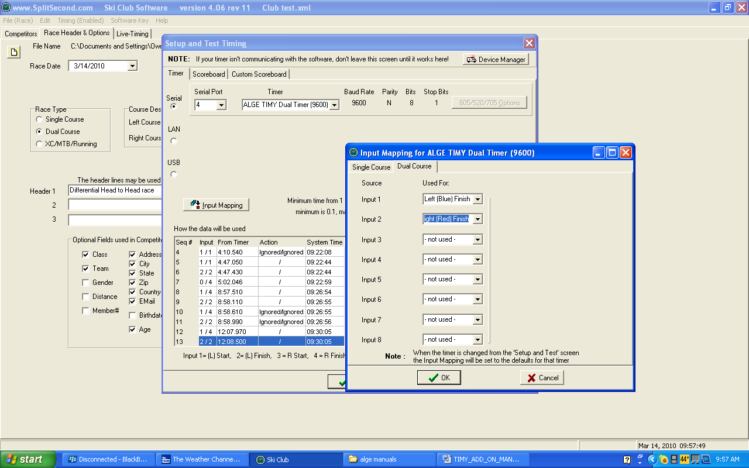

Then select ALGE TIMY Dual Timer (9600) in the drop down menu. This will now allow you to select INPUT Mapping. Select DUAL COURSE

Designate Input 1 = Blue Finish

Designate Input 2 = Red Finish

All others to “not used”

MAKE SURE you then select TIMY USB and retest connection before timing

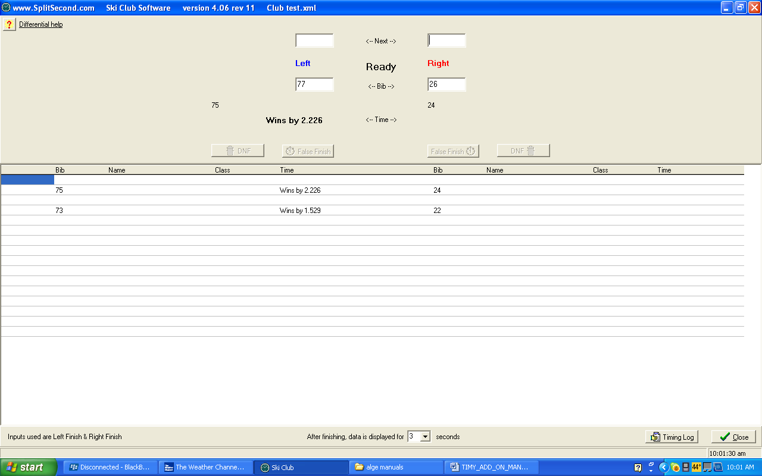

The screen shot shows that the Blue course Channel 0 input won. The Red course Channel 1 can either be the direct DIN connection to the photocell using the Red Stop cable or the Channel 1 banana plug inputs.

We recommend having an assistant out at the finish line to simulate these finishes prior to racing. You might have to switch the inputs into the TIMY to make the courses match your setup.

Support

- THE Phoenix Sports Technology discussion forum is a great place to start:
- http://timingguys.com/6/ubb.x OR www.timingguys.com
- Fred Patton can be reached on his worldwide cell phone at 610-972-5385
- The ALGE factory site has a great deal of information as well. You can download the latest manuals and brochures.
- www.alge-timing.com

NEW FOR 2011

The Split Second Website has a written documentation on interfacing the ALGE TIMY and TIMY2 to National/FIS.
http://splitsecond.com/wiki/index.php/Timers
If you want to have video assistance try the SkiRaceHelp channel on YouTube.
http://www.youtube.com/watch?v=NXzqzX48WqM

Windows 7 connection for TIMY

http://algetiming.com/alge/download/manual/timy/Timy%20Driver%20installation%20Win7-E.pdf

Windows 8 notes from ALGE (at bottom of webpage)

http://alge-timing.com/download/Software/Driver/index-1e.html

