Interfacing ALGE S4 timer
NATIONAL/FIS, Club, NASTAR software by Split Second.

Choose the default value of 4800 baud, N,8, 1 with the COM 1 (or other legal COM port seen in Windows Device Manager) in the "setup and test" menu. Click on the "view raw data" button so that you can see the times
coming in.

USB to Serial adapters

- USB to serial adapters must work under Windows first before the software can recognize them.
- These adapters assign themselves to COM 4> 9 depending on how they are installed.
- Try to keep the COM Port in the 4.6 range. Reinstall driver by going on manufacturers website and downloading current version
- Reboot PC and then plug in adapters prior to checking
- Plugging a USB to Serial adapter into another slot on the PC will cause it to be assigned another Com port number
- Always try to buy a PC with a built in Serial port. Dell Latitude PCs with Windows XP Pro are your best bet.

Set up the S4 in program 3.

- Hold the toggle switch up. Turn timer on. Release.
- Press yellow button until Pr 3 appears. Press red and yellow together to confirm.
- Press Yellow followed by Red to enter “HP” mode
- Input Hours with Red button, Minutes with Yellow
- Start by depressing toggle switch to “delay” or by a pulse on Banana socket “0” in the rear (Channel 0) S4 is now in "time base PC" mode and will send out data with channel ID and "time of day".
- Check the S4 manual under 18 channel timer (program 3) pages 33 thru 37 for more details.

Currently the software prefers to work properly with the banana plug starts and the photocell finishes directly above. We recommend using Channel "A". Channel A start banana is CH 0, Photocell input is 1. These are the default settings in the software. Use a din connector to input times to those channels. Pin 3 is ground, Pin 2 is signal.

The DB25 connector can also input Finish pulses. Pin 12 is common ground, Pin 14 is Red finish Channel 1, Pin 18 is Blue course finish Channel 4

Move to the timing window. You should now be able to have forerunners move down the simulated hill by giving impulses to each start and finish on
the S4.

Always use a ALGE P5 printer (Martel or Seiko) with this or any other timer.

Always flush your S4 memory prior to starting a timing session.

The CLR. JA message should appear when you turn the timer on. If it doesn’t you run the risk of overloading the memory. The S4 WILL NOT transmit times to the PC after 8000 splits have been recorded. The FULL message tells you how many have been used thus far.

To Program CLR. JA

- Hold toggle switch up and turn timer on, release
- Press toggle switch up again
- Press Yellow button at CLR. Nein message until it shows CLR. JA
- Press Red and Yellow together to save setting
- Now go and program the setting to Program 3 again if needed.

Testing impuses

- The S4 is a little bit of a pain in this regard. Get a paper clip and make a jumper out of it to short the banana plug inputs
- Try to work with the banana plug inputs first to get impulses recorded
- The Red ALGE stop cables are almost certain to work if they are in good shape and you can be assured that cells are lined up. Trust the fact that the Finish will work if the software is reading the start pulses.

Delay times on the S4

- The delay settings for all channels is handled by the DF setting
- Press the delay toggle switch down once
- The default setting is 2 - 10ths
- You can increase this by 10ths every press of the Red button
- Press Red and Yellow together to save settings

Cabling

- PST sells the S4 to PC cable for $45.00
- The DIN connector has pins 4-5 jumped to force the data transmission (CTS-RTS)
- Pin 2 (6 o’clock if looking down ready to solder) is Ground
- Pin 1 ( 2 o’clock if looking down ready to solder) is Signal
- Pin 5 is ground on the DB 9 serial connector
- Pin 2 is signal input on the Db serial connector

Global reset of timer

- There are times when you may get discouraged because everything else seems ok but the data seems to be corrupted.
- It usually takes two people to do the reset.
- Hold the Toggle Switch UP to Program/Line test and the Yellow button down at the same time. You assistant then turns the timer ON from behind
- The S4 will be reset to CLR. Nein and Program 0
- Reprogram to Program 3 and CLR. JA
- Resync and try again

Flashing all 888888 on LCD

- This happens when the Red and Yellow buttons are held down too long when confirming CLR. JA
- Try pressing Yellow first, then Red to confirm CLR. JA

SUPPORT

- The Phoenix Sports Technology discussion forum is a great place to start:

- http://timingguys.com/eve/forums OR www.timingguys.com

- Fred Patton can be reached on his worldwide cell phone at 610-972-5385

- http://www.timingguys.com/pstpdf/s4_manual.pdf

- The ALGE factory site has a great deal of information as well. You can download the latest manuals and brochures. www.alge-timing.com

NATIONAL/FIS SCREEN SHOT

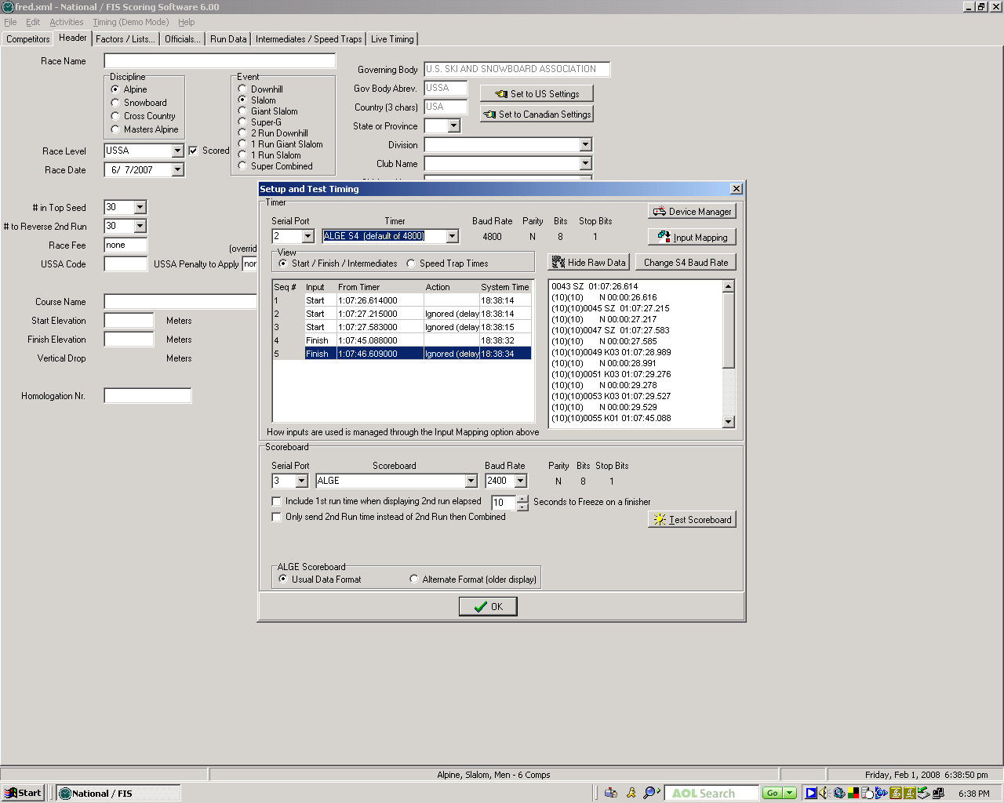

CLUB SCREEN SHOT

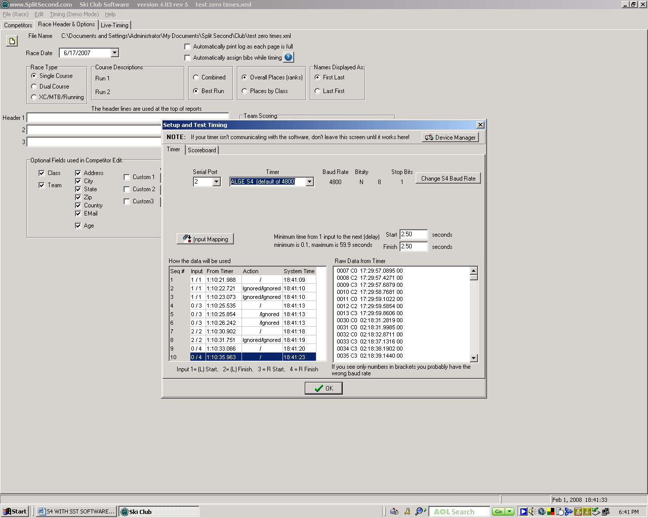

NASTAR SCREEN SHOT

